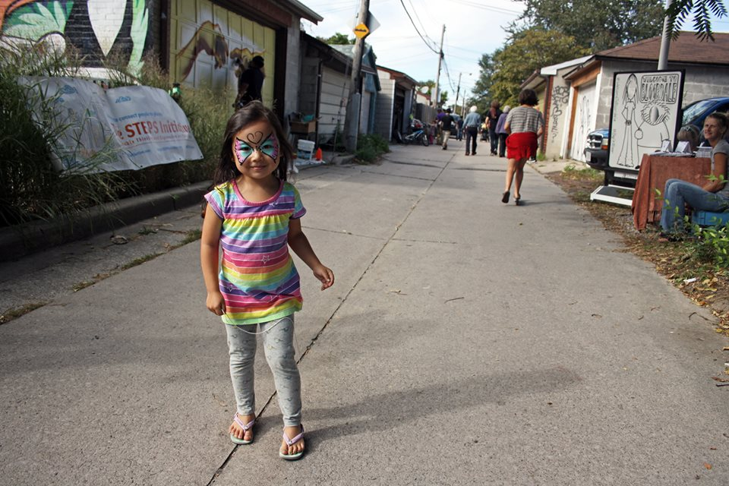
March 2016
Prepared by: The Laneway Project

HOW-TO GUIDE:

THROW A LANEWAY EVENT
Contents

1. About This Guide 3
2. Why Throw a Laneway Event? 5
3. Step-By-Step Guide 6
Procedures, Key contacts, Online resources, Permits required, Budget range, Potential funding sources
4. Laneway Event Examples 8

- ABOUT THIS GUIDE
This guide describes the process of organizing a laneway event
Throwing a laneway event is an excellent way to bring your community together, whether for a particular cause or just to have fun! This guide introduces the process of throwing a laneway event, and includes a general procedure and examples of successful laneway events from around the world. It also includes ideas of potential funding sources, permits that may be required and local key contacts that can help with organizing an event.

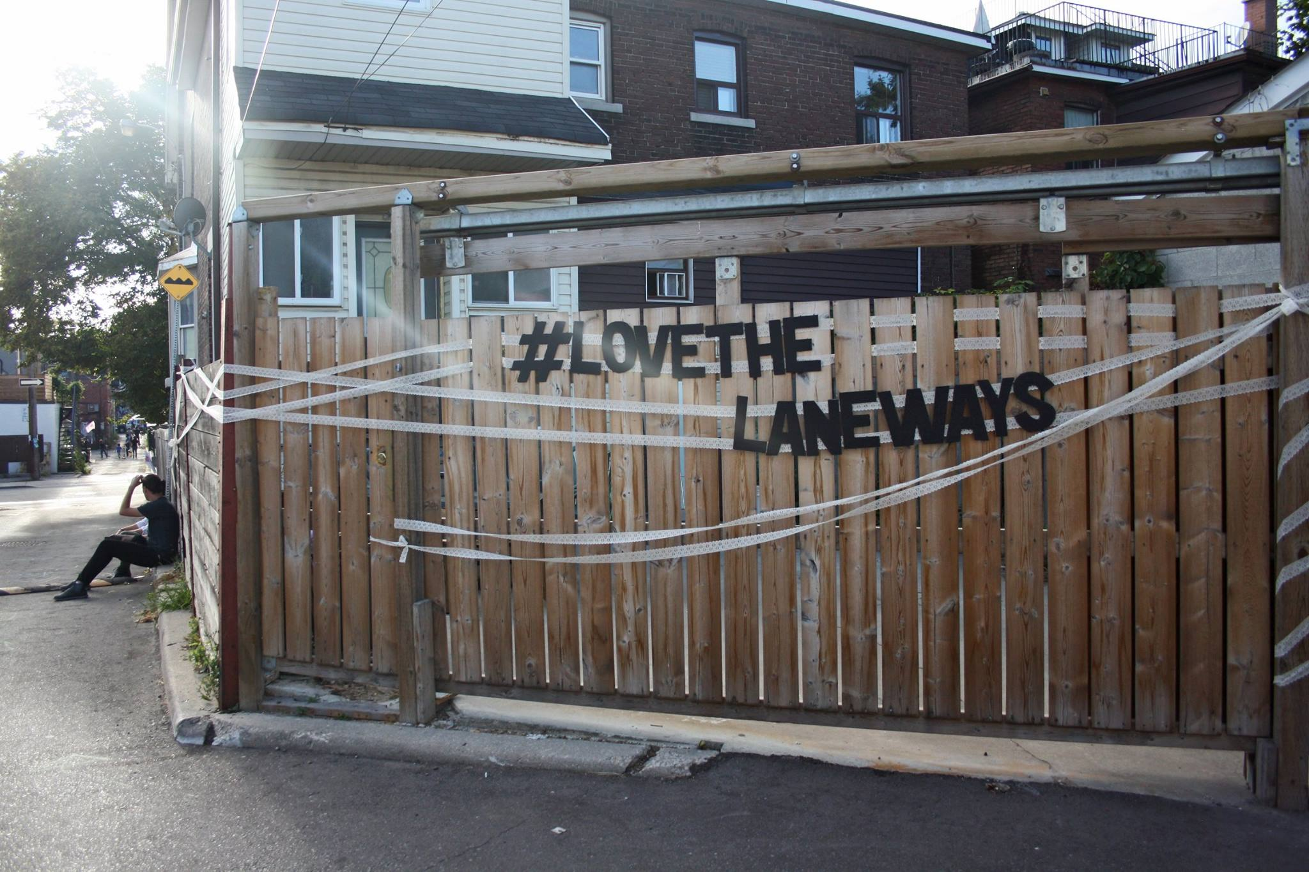
Image Credit: Katrina Afonso

.

Bloordale Laneway Crawl, September 2015
Image Credit : Katrina Afonso
- WHY THROW A LANEWAY EVENT?
There are more than 250 kilometres of laneways in Toronto, which are largely underused and underappreciated. However, these laneways can be beautiful, intimate and human-scale public places to hold local events and bring your neighbourhood closer together. A pop-up laneway event can help your community to understand the potential of your local laneways, and can demonstrate how important having a well-kept laneway can be for the neighbourhood. It can also give your community a sense of ownership of its laneway spaces, encouraging neighbours to care for and maintain them as vibrant public spaces. Laneways events can include:
- Farmers’ markets
- Annual laneway cleanup days
- Music and art festivals
- Laneway Crawls
- Community potlucks
- Laneway greening days
- Movie nights
- Garage sales
- Laneway street art days (refer to How To Guide: Add A Laneway Mural for more detail).
*Please note that Toronto’s laneways are used as service and emergency access routes; therefore any fixed set up (tables, chairs, booths, equipment) must be placed in adjacent non right-of-way space such as parks, garages, parking pads, and backyards. For tips for specific types of laneway event see Section 4 (Laneway Event Examples).
By throwing a laneway event, you can:
- Promote the uniqueness of your neighbourhood;
- Build ties within your community;
- Tap into the potential of your neighbourhood’s laneways as shared spaces;
- Provide a venue for local art and music;
- Increase awareness of and provide grass roots level marketing for local businesses;
- Visibly claim the neighbourhood’s laneway spaces for community use; and
- Build awareness of your neighbourhood’s laneway spaces and buy in for more permanent laneway improvements
.
- STEP-BY-STEP GUIDE
  - Small Community Events
There are some many different events you can host in a laneway. One of the simplest is to host a community gathering or neighbourhood party. There is no one way to do it, but here’s some things we recommend:
Have Food
The simplest way to provide food is to have a potluck or barbecue, where the residents bring the food themselves. (In order to keep things safe, it is suggested to advise those bringing food to review the City’s recommendations for food handling and preparation, available here: Food Safety).

*Please be aware that the option of selling food, or featuring food vendors, requires a permit from the City. For more information about this option please see the section below on Organizing a Large-Scale Event/Party in Toronto, or the City document on Temporary Food Establishment Permits.

As for tables and chairs, you may wish to rent these from an equipment store, borrow them from a local institution, or arrange with the attendees to bring their own chairs, and enough tables to accommodate everyone.

As noted above in Section 2, Toronto’s laneways are used as service and emergency access routes; any fixed set up (tables, chairs, booths, equipment) must be placed in adjacent non right-of-way space such as parks, garages, parking pads, and backyards.

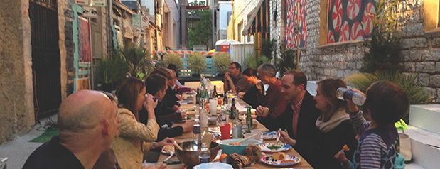

Have Games and Interactive Activities (including kid-friendly and teenager-friendly activities)
Face painting, balloon/egg toss, item-swap table, chalk-drawing contest, board games/life-sized games (like chess/checkers, scrabble, or twister), musical chairs, bobbing for apples, bottle bowling, street hockey/basketball etc.

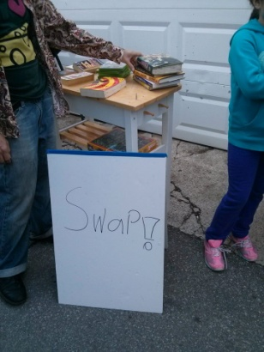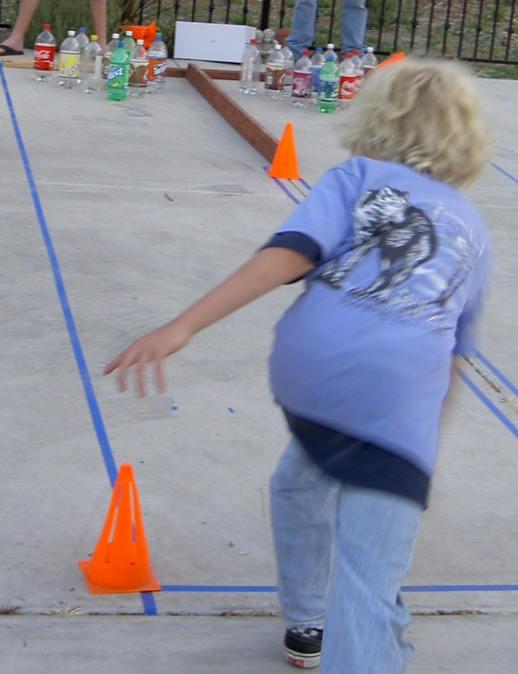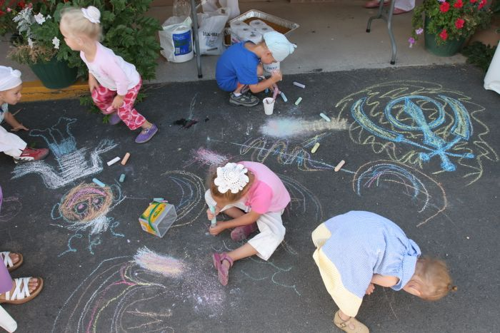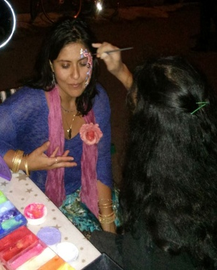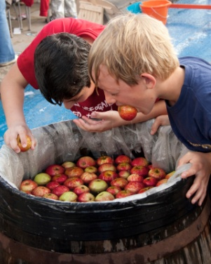

Have Music
If you’d like to keep things simple, you may just want to bring out a laptop or stereo, and put on a music mix, or have one of the more responsible kids play DJ. If you choose to have live music, one simple option is to ask friends and neighbors to recommend someone they know. Alternatively, you can consult a resource that connects event planners with music acts, such as this one: http://www.eventsource.ca/music-bands

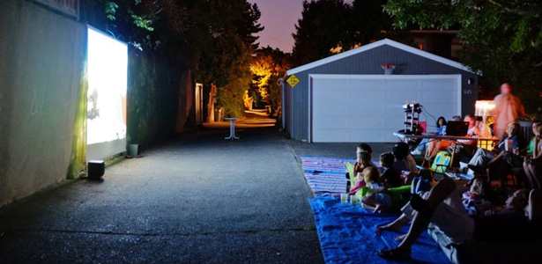
Have a Laneway Movie Screening
Why not follow up your potluck dinner/barbecue and activities with a movie screening for when the sun goes down. Just drape a white sheet over a wall or garage door, and set up a digital projector. Again, be sure to leave a lane for any vehicles to pass.

Image: http://www.theatlantic.com/national/archive/2011/09/is-urbanism-without-effort-the-best-urbanism-of-all/244965/

*For more ideas on potential activities, see these resources: Streetparty.org.uk, eHow: How to Throw a Block Party
Event To-Do List

Invite the Community
Inform the residents whose properties abut the laneway that you will be having a laneway event (and what activities will be taking place), request their attendance, and leave a contact number and/or online platform for any concerns/suggestions they may have. The easiest way to do this is often to drop a flyer in the mailboxes of the affected parties. Here’s a possible template: Community Laneway Event Flyer

*We recommend setting up a Facebook group for the event where all the attendees can share information and leave notes. Just create the group beforehand, and include the address on the flyer.

Pre-Event Clean-Up
If the laneway needs a clean-up, you may want to organize such a clean-up just before the event (one option is to recruit volunteers, and make it part of the event itself).

Traffic
Make sure any tables/chairs and equipment you set up leaves ample space (at least 3 meters) for cars and emergency vehicles to pass by.

Bathrooms
Make sure there are bathroom facilities available (the Ossington Village Alleyway Party rents a couple of port-a-potties, which is the only expense for the party, and paid for through attendee donations).

Post-Event Tidy up
Make sure all the garbage is cleaned up, and the site is tidy following the event.

  - Large Events
If you’re planning a larger event, there some additional steps involved. This section provides a cheat sheet for organizing a large laneway event. Each step may not be necessary for every event – you’ll need to mix and match to arrive at the procedure that’s right for your unique event.
- Form an Events Working Group. This might include representatives of your residents’ association, local BIA, active local business, active local cultural organizations, local councillor and property owners.

- Meet with your Events Working Group:
  - Decide on goals for your laneway event – what would you like to do? Have a music festival? Organize a street art day? Green your laneway?
  - Brainstorm potential allies – who should you be reaching out to for activities and laneway-side space?
  - Create a list of key people to contact.

- Reach out to your key contacts:
  - Introduce them to the event idea and outline its benefits and requirements
  - Encourage them to be involved, whether by providing event space, as activity coordinators or as event-day helpers
  - Secure the involvement of a critical mass of local stakeholders. Critical mass will depend on the type and scale of event that you are planning, but should be enough event space, activity coordinators and helpers to ensure that the event can be successfully executed.

- Secure any necessary permits.

- Create a map to show the proposed event space.

- Create an event flyer and storefront poster for local distribution:
  - Introduce the event concept
  - Show the event map
  - List the activity or activities that will be part of the event – a movie screening, music, food, seed planting or art-making, for example, depending on the nature of your event
  - Include contact email and information about the community workshop, if you’re planning to have one.

- Hand out flyers to adjacent property owners and tenants (email, in person) and distribute storefront posters to local business owners.

- Host a community workshop (mostly for multi-activity events like Laneway Crawls):
  - Brainstorm activation ideas
  - Recruit further activity leaders and activity sites.

- Follow up with adjacent property owners and tenants (email, in person):
  - Secure further activity sites, coordinators, activity leaders and event-day helpers.

- Finalize the map to show activity locations and activities.

- Create an event schedule including set-up time, start-time, schedule, end time, and clean-up.

- Coordinate event day
  - Quick clean-up of the laneway if necessary
  - Ensure event location is ready for setup
  - Help activity coordinators to set up event requirements
  - Supervise event
  - Help activity leaders with clean-up
  - Ensure that laneway and activity spaces are returned back to normal.
- Follow up with event space donors, coordinators, activity leaders and event-day helpers post-event to thank them and get their feedback.
Key contacts | List of Toronto BIAs:  - http://www1.toronto.ca/wps/portal/contentonly?vgnextoid=8e3032d0b6d1e310VgnVCM10000071d60f89RCRD  List of Toronto City Councillors:  - http://www1.toronto.ca/wps/portal/contentonly?vgnextoid=c3a83293dc3ef310VgnVCM10000071d60f89RCRD
Online resources | Noise exemption permit:  - http://www1.toronto.ca/wps/portal/contentonly?vgnextoid=548cabeba4471410VgnVCM10000071d60f89RCRD&vgnextchannel=2e4732e2e7741410VgnVCM10000071d60f89RCRD  Special occasion permit (sale permit for alcohol):  - http://www.agco.on.ca/en/whatwedo/permit_special.aspx  Temporary Food Establishment Permit:  - http://www1.toronto.ca/City%20Of%20Toronto/Toronto%20Public%20Health/Healthy%20Environment/DineSafe/Files/pdf/O/organizer_package%20AODA.pdf  Sidewalk Sale Permit:  - http://www1.toronto.ca/wps/portal/contentonly?vgnextoid=32b7a84c9f6e1410VgnVCM10000071d60f89RCRD&vgnextchannel=378c4074781e1410VgnVCM10000071d60f89RCRD  Community festival grant:  - http://www1.toronto.ca/wps/portal/contentonly?vgnextoid=76f9b57f973c2410VgnVCM10000071d60f89RCRD
Permits required | - Noise exemption permit (to allow amplified sound within a time frame)  - Special occasion permit (to allow alcohol to be served and alcohol tickets sold)  - Temporary Food Establishment Permit (to allow the sale of food)  - Sidewalk Sale Permit (to allow the sale of merchandise on public property)
Budget range | $
Potential funding sources | - Local BIA  - Community festival grant  - Crowdfunding  - In-kind contributions from local businesses and residents

- LANEWAY EVENT EXAMPLES

Below are some examples of laneway events from Toronto and around the world.

Farmers’ Market | 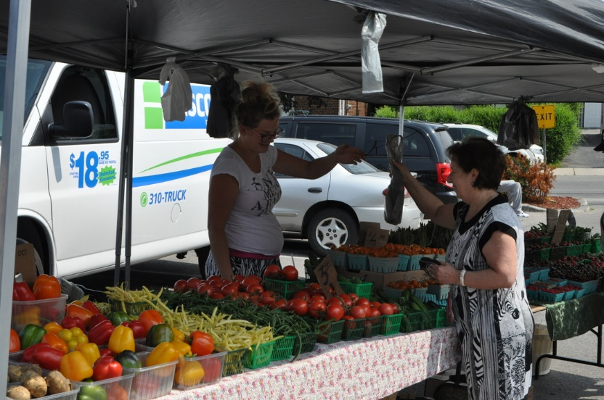  Image Credit: Eglinton Farmers’ Market  The York-Eglinton BIA held its first farmers’ market in the summer of 2015. The market was formed to promote the 200 businesses in the area along Eglinton Avenue West, between Marlee Avenue and Dufferin Street. It is also used to increase awareness for local food in Ontario.  Eglinton Farmers Market  http://www.eglintonfarmersmarket.com/  How to get a farmers’ market started:  http://www.farmersmarketsontario.com/Upload/Files/Pre-Readiness.pdf
Annual Laneway Cleanup Day | 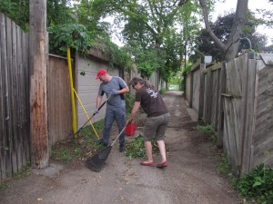  Image credit: cabbagetowner.com  Gordon Sinclair Laneway clean-up was organized by the Cabbagetown Residents Association and local residents following a safety walk. Neighbours were invited to attend and encouraged to bring their gardening gloves/tools (and enthusiasm), while the CRA provided refreshments, some gardening tools and supplies. The focus was on removing weeds and garbage from the laneway. Residents and/or homeowners are asked to clean and de-clutter their parking areas, ensure gates are in good working order. They also contacted 51 Division Graffiti Eradication teams to remove graffiti.  Clean Together Toronto:  http://www1.toronto.ca/wps/portal/contentonly?vgnextoid=d9236056e60c3410VgnVCM10000071d60f89RCRD&vgnextchannel=8131fbfa98491410VgnVCM10000071d60f89RCRD  Home Depot Community Grant: https://www.homedepot.ca/en/home/corporate-information/our-community/the-home-depot-canada-foundation/how-we-help/grant-programs.html
Laneway Greening Day | 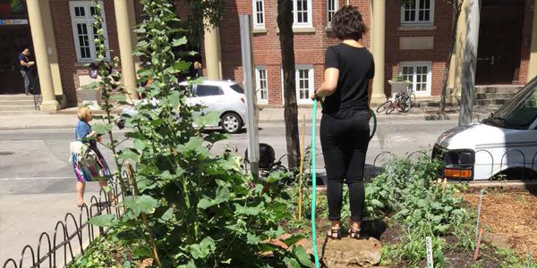 Rye’s Homegrown O’Keefe Garden. Image: Arts Eco Action  The Ryerson University community and other partners such as the Downtown Yonge BIA and The Laneway Project combined a laneway clean up and garden planting event for the O’Keefe Lane on October 2015. Volunteers were dedicated to gardening while others were dedicated to cleaning the laneway. Event details can be seen here:  http://www.ryerson.ca/arts/news-events/events/okeefe-laneway-cleanup.html
Music and Art Festivals | 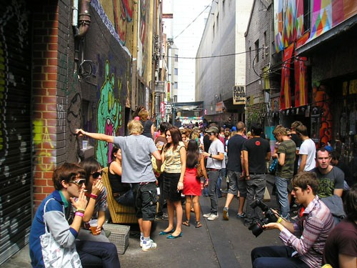  St. Jerome’s Laneway Festival, Melbourne  Image Credit: FasterLouder  http://fasterlouder.junkee.com/only-50-tix-left-to-adelaide-laneway-festival/790540  St. Jerome’s Laneway Festival started out in a small Melbourne bar hidden in a garbage infested alley in Caledonian Lane. It began with a couple of friends that wanted to have a couple of bands play shows every Sunday. Bands popped in for their “secret show” and the Summer Series, as they called it, became a sold out show and the festival began without anyone realizing they were in the making of one of the largest festivals in Australia.  http://auckland.lanewayfestival.com/more-info/history/
Laneway Crawl | 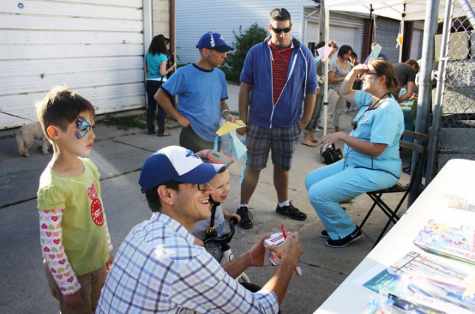  Image Credit: Katrina Afonso  The Laneway Project organized the Bloordale Laneway Crawl in September 2015, in two neighbourhood laneways. Different community groups led interactive activities on private property and in park space adjacent to the laneways, while the laneways themselves served as circulation space. The Susan Tibladi Parkette, at the intersection of the two laneways, provided additional space for some of the activities that transformed these laneways into active community space for the afternoon – including drum workshops by Ripple Rhythm, shown here. For more information, see http://thelanewayproject.ca/bloordale-laneway-crawl/
Community Potluck | 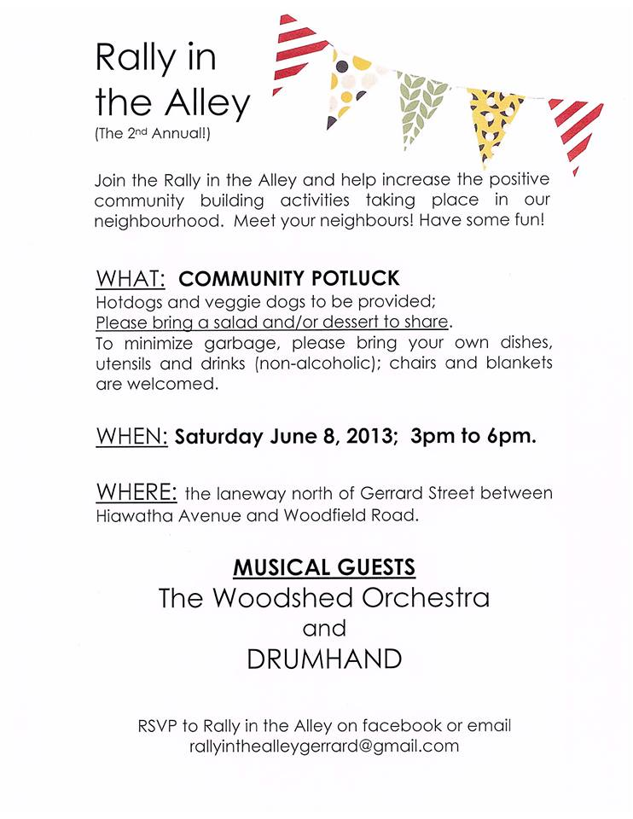  The East Leslieville neighbourhood in Toronto holds an annual potluck in conjunction with local bands in their community laneway. Organizers provide hotdogs while community members bring other food such as a salad and dessert to share with others. http://eastleslieville.ca/june-8-2013-rally-in-the-alley/
Movie Night | 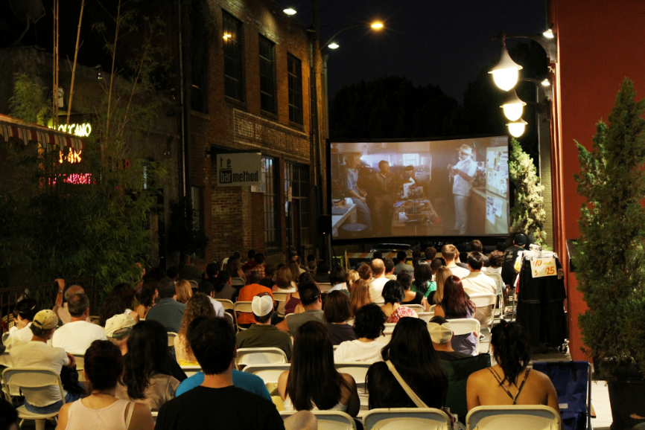  Image Credit: Hoopla Blog  A movie night can be a great tool for hosting old film festivals, Halloween events, and a family community event. The annual Old Pasadena Film Festival is an example where laneways have been used as venues to hold pop-up events like these. In 2010, Mills Alley and Hugus Alley were used to host movies such as Jurassic Park (1993) and The Way We Were (1973). Here in Toronto, TIFF can help out with arranging outdoor film screenings!  Old Pasadena Film Festival:http://www.oldpasadena.org/filmfestival/  Old Pasadena Film Festival 2011, California: http://hooplablog.com/film-fest-mills-alley-004/  TIFF in Your Park, Toronto: http://www.tiff.net/summer2015-series/tiff-in-your-park-map
Community Garage Sale | 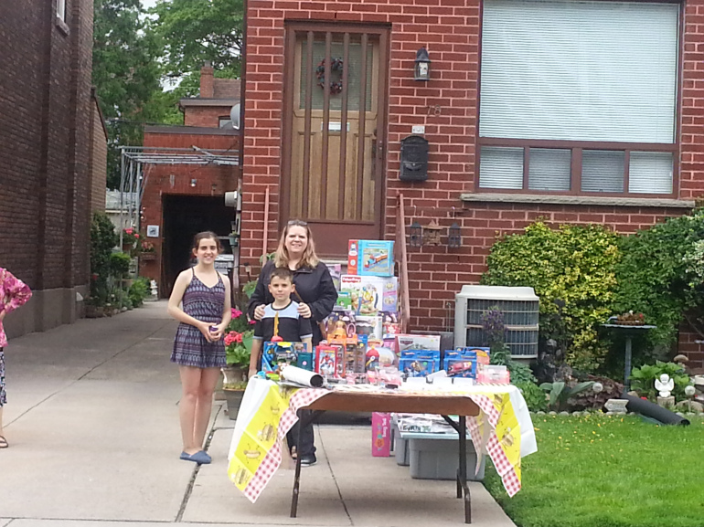  https://bloordalecia.wordpress.com/2015/03/24/2015-bloordale-community-garage-sale/  The annual Bloordale Community Garage sale was organized by the Bloordale Community Improvement Association (BCIA) committee and other local residents. The event was successful with more than 40 homes participating. This laneway event was the largest community garage sale in Bloordale.
Street Night Event | 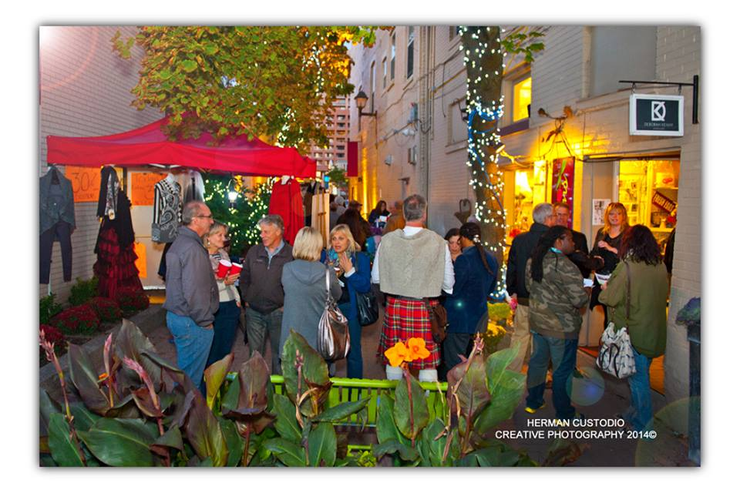  Photo Credit: Herman Custodio  “A Night in the Lane” - Brampton Laneway  Since September 2012, Brampton’s downtown business owners have come up with a creative way to utilize their local laneway to promote their goods through a free annual event called “A Night in the Lane.” This event takes place in McArter Lane and is used to stimulate and inspire the downtown core, as well as show that laneways are spaces that can be used in all sorts of ways. During the summer season, this laneway is also used as a farmer’s market, and during the Christmas season, a holiday open house takes places.  McArter Lane Events Page: https://www.facebook.com/eventsinthelane/

The Laneway Project is an independent planning and urban design-based not-for-profit that is transforming Toronto's relationship with its laneways. Our role is to initiate and implement demonstration projects to improve and activate laneways throughout the city, work with the City of Toronto and other stakeholders to create laneway-friendly policies and procedures, and inspire, empower and support communities in undertaking their own laneway projects.

Learn more at www.thelanewayproject.ca

